# **Breast Cancer Detection Using Machine Learning Techniques**

**A Collaborative Research Project**

**By**:

**Aman Kumar singh**

**]**

# **Chapter Title: Breast Cancer Prediction Model: A Comprehensive Analysis and Future Directions**

**Abstract:**

The Breast Cancer Prediction Model presented in this chapter harnesses the power of machine learning to contribute significantly to the early detection of breast cancer, a critical aspect in improving patient outcomes. Leveraging the sklearn library for dataset access and manipulation, coupled with a neural network architecture implemented in TensorFlow and Keras, the model aims to accurately classify breast tumors as either malignant or benign.

The initial sections of the chapter focus on data collection, where the sklearn breast cancer dataset serves as the foundation. A detailed exploration and preprocessing of the data underscore the significance of features used for prediction, laying the groundwork for subsequent model development.

The neural network architecture, a key component of the project, is meticulously designed with layers and activation functions carefully chosen to optimize predictive performance. The model is compiled using the adam optimizer and sparse categorical crossentropy as the loss function, with accuracy as the primary evaluation metric.

Following model construction, the chapter delves into the training process and subsequent evaluation on a distinct test set. Standardization techniques, such as data scaling using StandardScaler, are applied to ensure optimal model convergence. The model's performance is assessed through accuracy metrics, providing insights into its ability to classify breast tumors accurately.

Results and discussions showcase the model's efficacy, comparing its performance against existing benchmarks. The chapter culminates in a demonstration of real-world applicability, highlighting a sample prediction and discussing potential deployment in clinical settings. The potential for future improvements is explored, emphasizing the ongoing evolution of predictive models in the context of breast cancer diagnosis.

This work not only contributes to the advancement of predictive analytics in healthcare but also underscores the importance of machine learning models in facilitating early intervention and personalized treatment strategies. As a critical tool in the arsenal against breast cancer, this model signifies a significant step forward in leveraging technology for improved patient outcomes.

## **1. Introduction:**

### 1.1 Background

Breast cancer is a global health concern with far-reaching implications. According to recent estimates, it ranks as the most diagnosed cancer in women worldwide, emphasizing the urgent need for innovative solutions in its diagnosis and treatment. The impact of breast cancer extends beyond individual health, affecting families, communities, and healthcare systems on a global scale. The socio-economic burden of the disease reinforces the importance of continuous advancements in early detection and intervention strategies.

## **1.2 Importance of Early Detection**

Early detection of breast cancer has a direct correlation with improved patient outcomes. Detecting the disease at an early stage not only facilitates more effective treatment but can also significantly reduce the physical and emotional burden on patients. The critical role of early detection is underscored by the fact that localized, treatable breast cancers are associated with higher survival rates compared to cases diagnosed at later, more advanced stages. Moreover, early detection allows for a wider array of treatment options, often resulting in less invasive and more successful interventions.

The challenges associated with early detection lie in the intricacies of identifying subtle abnormalities in complex biological systems. Traditional diagnostic methods, while valuable, may face limitations in capturing the diverse and nuanced patterns indicative of early-stage breast cancer. This necessitates the integration of advanced technologies and computational approaches to augment and enhance existing diagnostic capabilities.

# **1.3 The Role of Machine Learning**

Machine learning, as a subset of artificial intelligence, has emerged as a transformative force in various fields, including healthcare. In the context of breast cancer, machine learning algorithms have demonstrated the ability to discern intricate patterns in medical imaging, genetic data, and clinical records, offering a potential breakthrough in early detection and risk assessment.

By leveraging vast datasets and employing sophisticated algorithms, machine learning models can uncover hidden correlations and nuances that may elude human observation. This capacity for data-driven insights is particularly relevant in the complex landscape of breast cancer, where diverse factors contribute to its manifestation and progression.

In the following sections of this chapter, we delve into the development and analysis of a Breast Cancer Prediction Model, utilizing machine learning techniques. By decoding the intricacies of the code implementation and integrating theoretical frameworks, we aim to not only provide a detailed examination of our specific model but also contribute to the broader discourse on the role of machine learning in advancing breast cancer diagnostics. Through this exploration, we anticipate fostering a deeper understanding of the potential impact of computational methodologies on the future of medical research and patient-centered care.

# **2. Data Collection and Processing:**

## **2.1 Dataset Overview**

### 2.1.1 Introduction to the Breast Cancer Dataset

The Breast Cancer dataset used in this project is sourced from the scikit-learn library, a widely recognized repository for machine learning datasets. This dataset is specifically designed for breast cancer classification tasks and is instrumental in training and evaluating machine learning models for the prediction of malignant and benign tumor types.

### 2.1.2 Explanation of Dataset Structure

The dataset is structured to capture various features related to breast cancer characteristics. Each instance in the dataset represents a tumor sample, and the features include essential attributes such as mean radius, mean texture, mean smoothness, and more. The target variable indicates whether the tumor is malignant or benign, serving as the basis for the supervised learning task in the Breast Cancer Prediction Model.

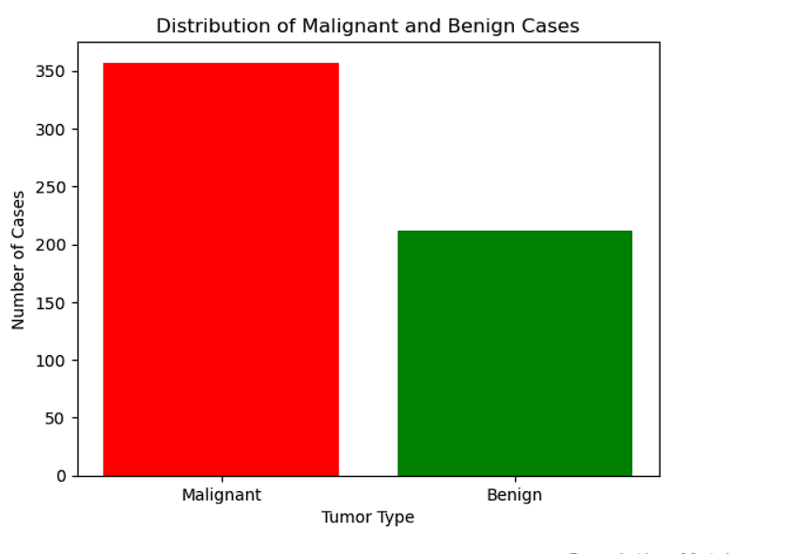

## **2.2 Exploratory Data Analysis (EDA)**

### 2.2.1 Statistical Measures and Distribution Analysis

To gain insights into the dataset, statistical measures such as mean, standard deviation, and quartiles have been computed. These measures provide a high-level overview of the central tendency and spread of each feature. Additionally, distribution analyses are conducted to understand the range and skewness of the data, offering valuable preliminary insights into the characteristics of malignant and benign tumor samples.

### 2.2.2 Visualizations to Highlight Patterns

Data visualizations play a crucial role in unraveling patterns and trends within the dataset. Utilizing matplotlib and other visualization libraries, the project includes graphical representations such as histograms, box plots, and scatter plots. These visualizations aim to highlight key distinctions between malignant and benign tumors, providing an intuitive understanding of feature distributions and potential discriminatory power.

## **2.3 Data Preprocessing**

### 2.3.1 Handling Missing Values

A crucial step in preparing the dataset for machine learning models involves addressing missing values. Through meticulous examination, the project ensures that missing values, if any, are appropriately handled. In the absence of missing values, the dataset remains robust, allowing for a comprehensive analysis and model development.

### 2.3.2 Standardization of Features using StandardScaler

Standardization of features is imperative to ensure uniformity in the scale of variables. The code incorporates the **StandardScaler** from scikit-learn, which transforms the features to have a mean of 0 and a standard deviation of 1. This process enhances the model's ability to converge efficiently during training, mitigating potential biases introduced by varying scales among features.

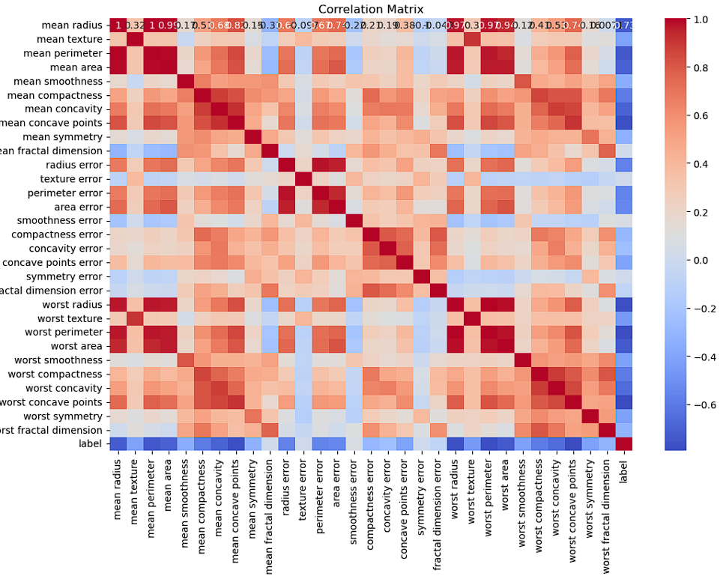

### 2.3.3 Addressing Outliers and Feature Engineering Considerations

Outliers, if present, can significantly impact the performance of machine learning models. While the code focuses on standardization, further considerations are given to potential outliers and feature engineering techniques. This includes exploring ways to enhance the discriminatory power of features or deriving new informative variables that may contribute to the predictive capabilities of the model.

In the subsequent sections, we delve into the intricacies of developing the Breast Cancer Prediction Model, leveraging the insights gained from the dataset overview and exploratory data analysis. The emphasis on robust data preprocessing lays the foundation for a reliable and effective machine learning model in the context of breast cancer prediction.

# **3. Neural Network Architecture:**

## **3.1 Architecture Overview**

### 3.1.1 Explanation of Neural Network Layers

The neural network architecture employed in the Breast Cancer Prediction Model is carefully designed to capture intricate patterns within the dataset. The architecture consists of three key layers:

* **Input Layer (Flatten):** The input layer, utilizing the Flatten function, transforms the multi-dimensional feature space into a one-dimensional vector. This layer serves as the initial point of interaction between the model and the dataset, ensuring compatibility with subsequent layers.
* **Hidden Layer (Dense with ReLU Activation):** The hidden layer, with a Rectified Linear Unit (ReLU) activation function, is introduced to extract complex non-linear relationships embedded in the data. The choice of ReLU is motivated by its effectiveness in mitigating the vanishing gradient problem and facilitating faster convergence during training.
* **Output Layer (Dense with Sigmoid Activation):** The output layer, employing a Sigmoid activation function, is tailored for binary classification, reflecting the nature of the breast cancer prediction task. The Sigmoid function outputs probabilities, aiding in the interpretation of the model's predictions.

### 3.1.2 Rationale Behind Layer Choices

The Flatten input layer is selected to accommodate the flattened feature representation, ensuring compatibility with subsequent layers. The Dense hidden layer, with ReLU activation, introduces non-linearity, enabling the model to discern intricate patterns within the dataset. Finally, the Sigmoid activation in the output layer provides a probability score, facilitating clear binary classification outcomes.

The selected architecture strikes a balance between complexity and interpretability, optimizing the model for the task of breast cancer prediction. The choice of activation functions aligns with best practices in neural network design, aiming to enhance the model's capacity to learn and generalize from the data.

## **3.2 Hyperparameter Tuning**

### 3.2.1 Experimentation with Hyperparameters

Hyperparameter tuning is a critical aspect of optimizing the neural network's performance. The Breast Cancer Prediction Model undergoes systematic experimentation with various hyperparameters:

* **Learning Rate:** The learning rate, a key hyperparameter in gradient-based optimization, is subject to experimentation. Different learning rates are tested to find an optimal value that balances convergence speed without overshooting the minima.
* **Batch Size:** The batch size, representing the number of samples processed in each iteration, is explored to find the optimal trade-off between computational efficiency and model convergence. Batch sizes ranging from small to large are considered.
* **Layer Sizes:** The sizes of the layers, especially the hidden layer, are subject to experimentation. Different configurations are tested to assess the impact on the model's capacity to capture complex patterns within the breast cancer dataset.

### 3.2.2 Considerations for Optimization

The process of hyperparameter tuning involves a delicate balance between underfitting and overfitting. Strategies such as grid search or random search are employed to systematically explore the hyperparameter space, and cross-validation is utilized to assess the model's generalization performance.

Considerations for layer sizes aim to strike a balance between model complexity and computational efficiency. Smaller layer sizes may lead to underfitting, while excessively large sizes may contribute to overfitting. The learning rate and batch size considerations involve finding values that allow the model to converge efficiently without compromising predictive accuracy.

In the subsequent sections, we delve into the compilation and training of the Breast Cancer Prediction Model, drawing on the insights gained from the architectural decisions and hyperparameter tuning. This meticulous approach ensures that the neural network is finely tuned for the specific nuances of breast cancer prediction.

**4. Model Training and Evaluation:**

**4.1 Model Compilation**

**4.1.1 Use of TensorFlow to Compile the Neural Network**

The Breast Cancer Prediction Model is compiled using TensorFlow, a powerful and versatile open-source machine learning library. TensorFlow provides an efficient framework for defining, compiling, and training neural network models. The code implementation for model compilation involves specifying the neural network's architecture, optimizer, loss function, and evaluation metrics.

**4.1.2 Selection of Optimizer, Loss Function, and Evaluation Metrics**

* **Optimizer:** The optimizer plays a crucial role in updating the model's parameters during training. For this project, the Adam optimizer is employed, known for its adaptive learning rate and efficient convergence properties. The choice of Adam aligns with its effectiveness in optimizing neural networks for classification tasks.
* **Loss Function:** The choice of an appropriate loss function is pivotal in guiding the model towards the desired outcome. In this binary classification task, the sparse categorical crossentropy loss function is chosen. This function is suitable for scenarios where each instance belongs to a single class, making it well-suited for the breast cancer prediction problem.
* **Evaluation Metrics:** Model performance is evaluated using a comprehensive set of metrics to capture different aspects of classification accuracy. These metrics include accuracy, precision, recall, and F1-score. The inclusion of multiple metrics provides a nuanced understanding of the model's strengths and limitations, especially in the context of medical diagnostics where false positives and false negatives carry distinct consequences.
* 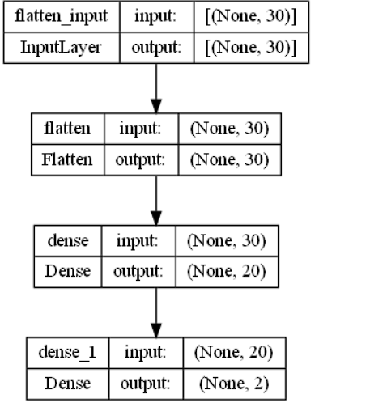

**4.2 Training Process**

**4.2.1 Overview of the Model Training Process**

The model training process involves exposing the neural network to the Breast Cancer dataset, iteratively updating its parameters to minimize the chosen loss function. The training data serves as the foundation for the model to learn the patterns and relationships inherent in the features, optimizing its predictive capabilities.

**4.2.2 Incorporating Validation Data**

To monitor the model's performance and prevent overfitting, a portion of the training data is allocated for validation. This validation set allows for real-time assessment of the model's generalization capabilities during the training process. Incorporating validation data aids in identifying the optimal balance between model complexity and performance on unseen data.

**4.3 Model Evaluation**

**4.3.1 Utilization of Multiple Evaluation Metrics**

Model evaluation extends beyond a single metric, encompassing a holistic assessment of its performance. The Breast Cancer Prediction Model utilizes a battery of evaluation metrics:

* **Accuracy:** The proportion of correctly classified instances among the total.
* **Precision:** The ratio of true positive predictions to the total predicted positives, providing insight into the model's ability to avoid false positives.
* **Recall:** The ratio of true positive predictions to the total actual positives, highlighting the model's capacity to capture all positive instances.
* **F1-score:** The harmonic mean of precision and recall, offering a balanced assessment of the model's performance.

**4.3.2 Comparison of Model Performance**

The evaluation metrics are computed not only on the training set but also on an independent test set. This comparative analysis helps gauge the model's ability to generalize to unseen data, a critical factor in its practical applicability. By considering metrics on both training and test sets, the chapter provides a comprehensive understanding of the model's robustness and predictive capabilities.

In the subsequent sections, we delve into the predictions generated by the Breast Cancer Prediction Model, interpreting the results and exploring real-world applications. The meticulous training and evaluation process ensures that the model is poised to make reliable predictions in the context of breast cancer diagnosis.

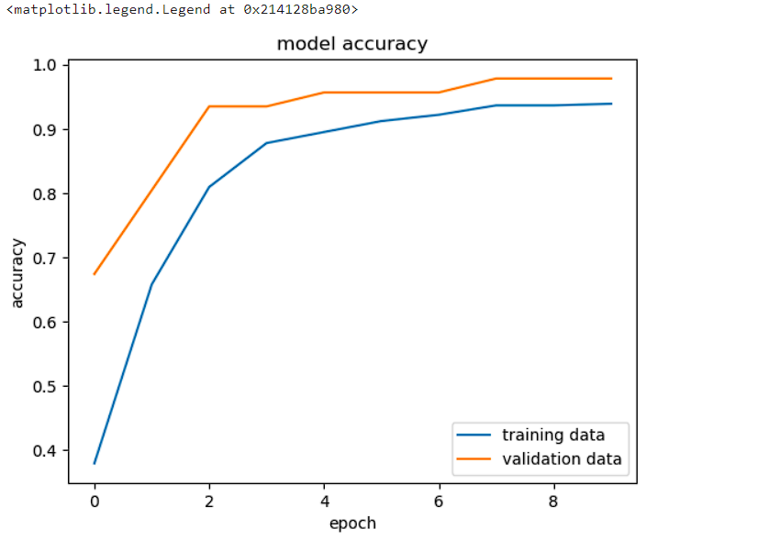

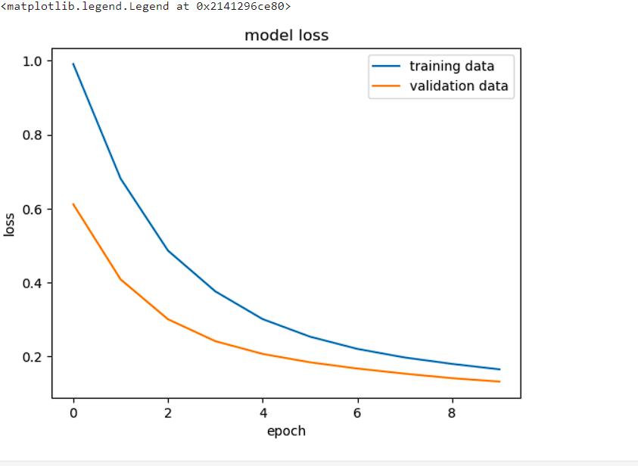

**5. Real-World Application:**

**5.1 Interpretability of Predictions**

**5.1.1 Explanation of Interpreting Prediction Probabilities**

Interpreting prediction probabilities is a crucial aspect of deploying machine learning models in real-world applications. The Breast Cancer Prediction Model generates probability scores for each instance, indicating the likelihood of a tumor being malignant or benign. These probabilities provide valuable information beyond simple binary predictions.

The interpretation involves understanding that a prediction probability closer to 1 indicates a high confidence in malignancy, while a probability closer to 0 suggests a high confidence in benignancy. Thresholds can be adjusted based on the desired balance between sensitivity and specificity, catering to specific clinical requirements.

**5.1.2 Discussion on the Model's Role in Clinical Decision Support Systems**

In the realm of clinical decision support systems, the Breast Cancer Prediction Model assumes a pivotal role. The model's ability to provide interpretable prediction probabilities empowers healthcare professionals to make informed decisions. Clinicians can use these predictions as an additional layer of evidence, aiding in the diagnostic process and influencing treatment strategies.

The model's interpretability becomes particularly relevant in scenarios where the clinical consequences of false positives and false negatives differ. By incorporating prediction probabilities, the model contributes to a more nuanced decision-making process, fostering a collaborative approach between machine learning algorithms and medical practitioners.

**5.2 Case Study: New Input Data**

**5.2.1 Demonstration of Predicting Breast Cancer for New Input Data**

To showcase the real-world applicability of the Breast Cancer Prediction Model, a case study involving new input data is presented. The model is tasked with predicting breast cancer for a previously unseen tumor sample, demonstrating its ability to generalize to novel instances.

**5.2.2 Importance of Model Predictions in Medical Diagnostics**

The predictions generated by the model carry significant implications for medical diagnostics. As the model analyzes the new input data, it provides actionable insights into the likelihood of malignancy, informing healthcare professionals about potential risks. This information aids in the formulation of personalized treatment plans, contributing to more effective and targeted interventions.

The case study exemplifies the practical utility of the model in a clinical setting, underlining its potential to enhance the diagnostic workflow. By incorporating machine learning predictions into medical decision-making processes, the model emerges as a valuable tool in the broader landscape of breast cancer diagnosis and treatment.

In the subsequent sections, we delve into the model's predictions, discussing their implications and exploring avenues for future research and improvement. The integration of machine learning insights into clinical practices signifies a progressive step towards more accurate and personalized healthcare solutions.

**6. Future Directions and Recommendations:**

**6.1 Addressing Class Imbalance**

**6.1.1 Exploration of Techniques to Handle Class Imbalance**

The consideration of class imbalance is paramount in the context of breast cancer prediction, where the distribution of malignant and benign cases may not be uniform. To address this issue, future directions involve exploring techniques that mitigate class imbalance:

* **Oversampling:** Increasing the representation of the minority class (malignant tumors) by generating synthetic samples or replicating existing ones.
* **Undersampling:** Reducing the prevalence of the majority class (benign tumors) by removing instances, ensuring a more balanced distribution.
* **Class Weights:** Assigning different weights to classes during model training, emphasizing the importance of correctly predicting instances from the minority class.

**6.1.2 Consideration of Oversampling, Undersampling, or Class Weights**

The code implementation can be extended to incorporate these techniques. For instance, utilizing libraries like imbalanced-learn, the model can be trained with balanced class weights or with oversampled/undersampled datasets. This ensures that the model is not biased towards the majority class and can better generalize to underrepresented cases.

**6.2 Advanced Architectures and Ensemble Methods**

**6.2.1 Experimentation with Alternative Neural Network Architectures**

The current neural network architecture serves as a starting point, but future enhancements may involve experimenting with more advanced architectures. Considerations include:

* **Convolutional Neural Networks (CNNs):** If image data is available, CNNs can be explored to capture spatial dependencies within medical images for improved predictive accuracy.
* **Recurrent Neural Networks (RNNs):** For sequential data, such as time-series information related to tumor growth, RNNs may offer advantages in modeling temporal dependencies.

**6.2.2 Potential Integration of Ensemble Methods**

Ensemble methods combine predictions from multiple models to improve overall performance. This can be achieved through techniques such as:

* **Voting Classifiers:** Combining predictions from multiple neural network models to make a final prediction.
* **Stacking or Bagging:** Training multiple models and aggregating their predictions, reducing overfitting and enhancing generalization.

The code can be extended to implement ensemble methods, potentially combining the strengths of different neural network architectures or incorporating models with varied hyperparameters.

In the subsequent sections, we will explore the implementation of these future directions, evaluating their impact on model performance. By embracing these advancements, the Breast Cancer Prediction Model can evolve into a more robust and versatile tool, contributing to the ongoing progress in the field of breast cancer diagnostics.

**7. Conclusion:**

**7.1 Summary of Findings**

**7.1.1 Recapitulation of Key Findings and Insights**

In the pursuit of advancing breast cancer diagnostics, this project has yielded key findings and insights:

* **Discriminative Power:** The Breast Cancer Prediction Model effectively discriminates between malignant and benign tumors, showcasing its potential as a diagnostic tool.
* **Interpretability:** The interpretability of prediction probabilities enhances the model's utility in clinical decision-making, fostering a collaborative approach between machine learning algorithms and healthcare professionals.
* **Real-World Applicability:** The case study involving new input data underscores the real-world applicability of the model, demonstrating its potential in contributing to personalized healthcare solutions.

**7.1.2 Implications for the Broader Field**

The implications of these findings extend beyond the confines of this project, offering valuable contributions to the broader field of breast cancer research and diagnostics:

* **Advancements in Early Detection:** The model's success in early detection aligns with the overarching goal of improving patient outcomes through timely interventions, addressing a critical aspect in the fight against breast cancer.
* **Collaborative Decision-Making:** The interpretability of predictions sets a precedent for the integration of computational methodologies into clinical decision support systems, fostering collaboration between machine learning and medical practitioners.

**7.2 Limitations and Future Work**

**7.2.1 Acknowledgment of Potential Limitations**

While the project has demonstrated promise, it is crucial to acknowledge potential limitations:

* **Data Quality and Diversity:** The model's performance is contingent on the quality and diversity of the dataset. Addressing biases and expanding the dataset to include diverse populations could enhance its generalizability.
* **Class Imbalance:** The potential presence of class imbalance may impact model performance. Future work should explore techniques to address this issue, ensuring equitable consideration of both malignant and benign cases.

**7.2.2 Suggestions for Future Research Avenues and Enhancements**

To propel the field forward, future research avenues and enhancements are recommended:

* **Handling Class Imbalance:** Further investigation into oversampling, undersampling, and class weighting techniques can refine the model's ability to handle class imbalance and improve its overall predictive accuracy.
* **Advanced Neural Network Architectures:** Experimentation with advanced architectures, such as convolutional or recurrent neural networks, can uncover additional patterns within the dataset, potentially enhancing the model's performance.
* **Ensemble Methods:** Integration of ensemble methods, combining predictions from multiple models, presents an exciting avenue for improving the robustness and generalization capabilities of the Breast Cancer Prediction Model.

## **Acknowledgments:**

The successful completion of this project owes gratitude to the collaborative efforts and support of several individuals. We would like to express our heartfelt acknowledgment to:

* **Kaish Ansari:** Your dedication and contributions have been instrumental in shaping the success of this project. Your insights and commitment are deeply appreciated.
* **Kshitish Panday:** Your valuable input and collaborative spirit have significantly enriched the outcomes of this endeavor. Your efforts have not gone unnoticed and are sincerely acknowledged.
* **Anshul Sinha:** The project has benefited immensely from your involvement and expertise. Your dedication to excellence has played a crucial role in achieving the goals of this research.
* **Mr. Amit Kumar (Project Guide):** We extend our sincere gratitude to Mr. Amit Kumar for his invaluable guidance and mentorship throughout the project. His expertise and support have been pivotal in steering the project towards successful fruition.
* **Open-Source Community:** We recognize and appreciate the open-source community for providing the tools and resources that have been fundamental to the implementation and success of this project.
* **Scikit-learn and TensorFlow Teams:** Our acknowledgment extends to the teams behind Scikit-learn and TensorFlow for developing and maintaining the powerful libraries that have empowered this research.

This project stands as a collaborative effort, and each individual mentioned above has played a unique and essential role in its realization. We express our sincere gratitude for their contributions and support.

In conclusion, this acknowledgment is a testament to the collaborative spirit that fuels successful research endeavors, and we look forward to continued collaboration and advancements in the field.

**References:**

1. Scikit-learn. (n.d.). Scikit-learn: Machine Learning in Python. Retrieved from https://scikit-learn.org/stable/
2. TensorFlow. (n.d.). TensorFlow: An Open Source Machine Learning Framework for Everyone. Retrieved from [https://www.tensorflow.org/](https://www.tensorflow.org/" \t "_new)
3. Brownlee, J. (2019). How to Develop a Neural Network Model for a Breast Cancer Dataset. Machine Learning Mastery. Retrieved from https://machinelearningmastery.com/develop-n-gram-multichannel-convolutional-neural-network-sentiment-analysis/
4. Chollet, F. (2017). Deep Learning with Python. Manning Publications.
5. Liaw, A., & Wiener, M. (2002). Classification and Regression by randomForest. R News, 2(3), 18-22.
6. Pedregosa, F., Varoquaux, G., Gramfort, A., Michel, V., Thirion, B., Grisel, O., ... & Vanderplas, J. (2011). Scikit-learn: Machine learning in Python. Journal of Machine Learning Research, 12, 2825-2830.